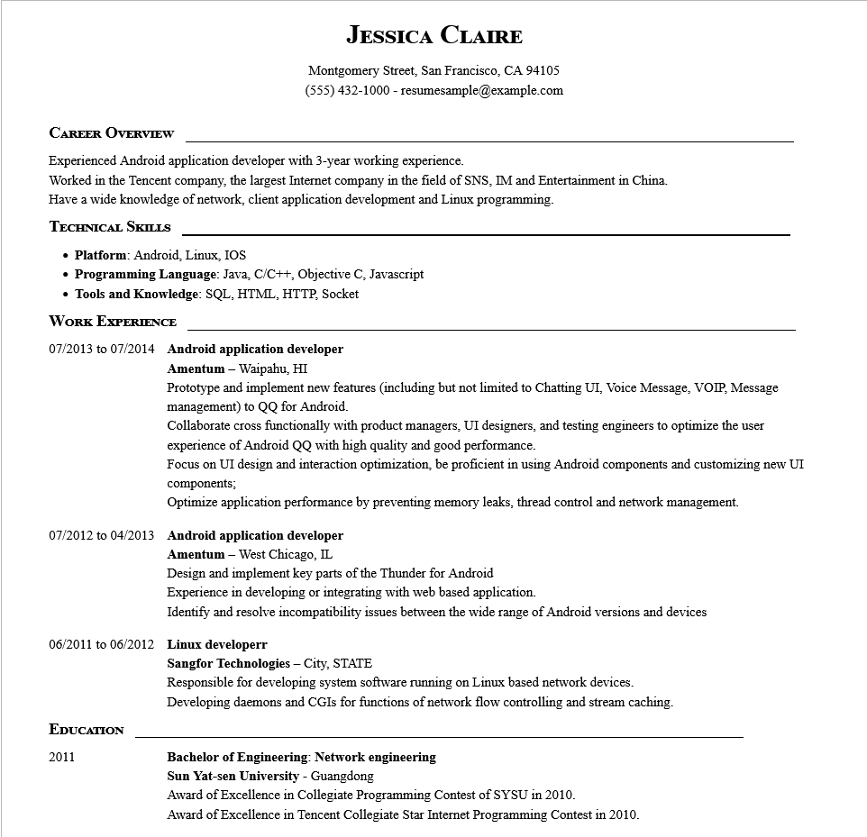
CAREER OVERVIEW
JESSICA CLAIRE
Montgomery Street, San Francisco, CA 94105
(555) 432-1000 - resumesample@example.com
Experienced Android application developer with 3-year working experience.
Worked in the Tencent company, the largest Internet company in the field of SNS, IM and Entertainment in China. Have a wide knowledge of network, client application development and Linux programming.
TECHNICAL SKILLS
• Platform: Android, Linux, IOS
• Programming Language: Java, C/C++, Objective C, Javascript
• Tools and Knowledge: SQL, HTML, HTTP, Socket
WORK EXPERIENCE
07/2013 to 07/2014 Android application developer Amentum - Waipahu, HI
Prototype and implement new features (including but not limited to Chatting UI, Voice Message, VOIP, Message management) to QQ for Android.
Collaborate cross functionally with product managers, UI designers, and testing engineers to optimize the user experience of Android QQ with high quality and good performance.
Focus on UI design and interaction optimization, be proficient in using Android components and customizing new UI components;
Optimize application performance by preventing memory leaks, thread control and network management.
07/2012 to 04/2013 Android application developer
Amentum - West Chicago, IL
Design and implement key parts of the Thunder for Android
Experience in developing or integrating with web based application.
Identify and resolve incompatibility issues between the wide range of Android versions and devices
06/2011 to 06/2012 Linux developerr
EDUCATION
2011
Sangfor Technologies - City, STATE
Responsible for developing system software running on Linux based network devices. Developing daemons and CGIS for functions of network flow controlling and stream caching.
Bachelor of Engineering: Network engineering
Sun Yat-sen University - Guangdong
Award of Excellence in Collegiate Programming Contest of SYSU in 2010.
Award of Excellence in Tencent Collegiate Star Internet Programming Contest in 2010.

